CCT College Dublin

Assessment Cover Page
To be provided separately as a word doc for students to include with every submission

Module Title: | Advanced Data Analytics  Big Data Storage and Processing
Assessment Title: | Integrated CA1 Sem 2 MSc in Data Analytics
Lecturer Name: | David McQuaid  Muhammad Iqbal
Student Full Name: | Liam Croash
Student Number: | sbs23036
Assessment Due Date: | 27/September/2023
Date of Submission: | 27/September/2023

Declaration

By submitting this assessment, I confirm that I have read the CCT policy on Academic Misconduct and understand the implications of submitting work that is not my own or does not appropriately reference material taken from a third party or other source. I declare it to be my own work and that all material from third parties has been appropriately referenced. I further confirm that this work has not previously been submitted for assessment by myself or someone else in CCT College Dublin or any other higher education institution.

Forecasting Methodologies in a Big Data Context

Abstract— This paper examines the practical application of neural networks in the context of big data analytics, with a particular focus on improving time series analysis. We consider the current landscape of data storage, with an emphasis on the need for efficient and cost-effective modelling and preprocessing techniques/ platforms. The paper discusses the selection of data storage architectures, cloud-based and on-premise solutions, and the consideration of workforce skills, tech debt and cost for infrastructure management. With a focus on financial forecasting for a large retail business, the paper compares advanced processing tools, machine learning technologies, and neural networks to determine the most effective ways to improve forecast accuracy. We presents a comparison of various time series analysis methods, including classical statistical approaches, machine learning models, and deep learning neural networks, highlighting their strengths and weaknesses in handling datasets with slightly different compositions.. (Abstract)
Keywords— Big Data, Neural Networks, Forecasting.

Introduction
he cost of storage media in the modern world has decreased considerably over the last decade. There is, however, an abundance of hidden costs involved with storage e.g., infrastructure, human. (Dutta, Amit & Hasan, Ragib. (2013), Suleykin, A., Bobkova, A., Panfilov, P. and Chumakov, I. (2021)). This has put an increased pressure on data practitioners to improve modelling / preprocessing techniques to maximise data readiness and to improve the throughput of data analysis and model development by minimising compute resources and delivering business value.
Data storage architectures (Nambiar, A. and Mundra, D. (2022)) offer a variety of advantages depending on individual use cases, so the need for businesses to understand and leverage the correct technologies is crucial in maintaining a competitive advantage and business viability. This also leads to considerations of cloud based vs on premise and leveraging existing skills within the workforce or acquiring new skilled workers to build and maintain new infrastructure.
Effective financial forecasting is a pivotal process for businesses to engage with. Robust forecasts can indicate opportunities for growth or highlight risks / areas for improvement within the operation of a business. Whether in target setting for organisational growth, projections for category performance or in predictions in expected production capacity; the need for an accurate representation of the future can drive business operations and initiatives.
With the increase in storage capacity, advances in processing tools, research into ML technologies that leverage deep learning and more sophisticated versions of classical forecasting techniques (Fajardo-Toro, C., Mula, J. and Poler, R. (2019), CQF, V.M., PhD, MBA (2023)), the availability of techniques to help business plan and execute more effectively have never been so available.
This paper will review various storage mediums, processing architectures and ML modelling approaches that can serve to maximise the ROI of data analytics programs that drive business intelligence.

CHOICE OF TECHNOLOGY

Data Storage Platform
Modern data storage is migrating towards cloud based platforms that have scalable storage and compute, are easily maintainable, offer integration with processing tools, sophisticated analysis tools, ETL and CI/CD automations. The 3 main competitors, (Amazon, Microsoft, Google) in the infrastructure as a service (IaaS) offer a variety of storage solutions for data storage and warehousing e.g. redshift, bigquery, azure sql data warehouse and all of these solutions are built on top of a Hadoop (HDFS) architecture with proprietary management software; google –Dataproc, AWS – elastic map reduce, Microsoft – ADFS. Hadoop is a distributed storage and processing environment that has proven to be highly scalable, fault-tolerant, and cost-effective. It is highly capable of handling large volumes of unstructured or semi-structured data, making it the primary choice for big data storage and processing.
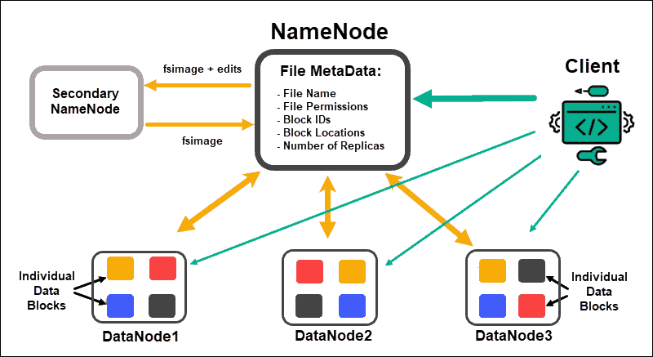
Figure 1: Hadoop storage architecture (Phoenix NAP (2020))
The 5 main advantages of using a Hadoop architecture for storage include:
Scalability: Hadoop can handle large volumes of data by distributing it across a cluster of computers, ensuring that data is efficiently processed and stored.
Cost-Effectiveness: Hadoop is open-source and uses commodity hardware This makes it a more affordable solution compared to traditional database systems. Storage and processing is accomplished at a fraction of the cost
Flexibility: Hadoop can store various types of data, including structured, unstructured, and semi-structured data, enabling businesses to analyze different data types collected from various sources.
Fault Tolerance: Hadoop’s architecture is designed for fault tolerance. Even if a node fails, data processing can continue uninterrupted as data is replicated across multiple nodes in the cluster.
Integration: Hadoop easily integrates with existing systems and applications, providing organizations the ability to enhance their data processing and analytics capabilities without significant overhauls or investments.
In the context of this project, we will be storing data of 50k customers from a dataset with 117 weeks of transactions from 500k customers with 5k individual products for > 300M transactions across 760 stores. (dunnhumby (2023a), dunnhumby (2023b)). Each sample CSV contains 1 day of transactions at a product level granularity. In this case, using Hadoop as an intermediary storage platform before further processing represents an ideal case for scalable, cost effective, fault tolerant platform that integrates with a wide array of warehousing, processing and ETL tools.

Data Processing
While Hadoop's strengths in data storage and management are undeniable, the evolving landscape of data analytics and processing demands more agile and real-time solutions. In the case of this project, we are concerned with forecasting sales for different store formats but this use case could easily extend into product or customer level forecasting to power recommendations or low latency ordering of materials.
The MapReduce model in Hadoop, while reliable and scalable, operates on batch processing. It is ideal for handling very large datasets and complex computations, but it can introduce latency in the data processing pipeline. This characteristic makes it less suitable for scenarios requiring real-time data processing and quick iterative algorithms, crucial for transactional datasets feeding into forecasting algorithms.
In contrast, Apache Spark emerges as a more fitting solution for such use cases. Its in-memory data processing capabilities significantly reduce the time taken for data processing making it an excellent fit for real-time analytics. Spark's agile nature allows for the quick development of solutions and flexibility in changing analytics workflows. It supports a wide range of data processing tasks, from batch to streaming processing, making it a versatile choice for diverse analytical requirements. This is with a preface that the data must be partitioned in a balanced tely to avoid performance lapses (Leturgez, L. (2020)). In cases where the Spark workload is not efficiently managed, the performance gains are lost as data is not efficiently processed in parallel and memory constraints can cause Spark to read from disk rather than from memory. When efficiently managed, Spark has a consideration performance advantage over MapReduce (Pan, Shengti (2016)). In terms of accessibility, Spark also provides a richer more familiar API, for Python, Scala and R, to data scientists and engineers as well as having an interactive mode, a robust ML library and a built in task scheduler. (Madhugiri, D. (2022)).

Analytcis Lifecycle
While MapReduce has the flexibility to run parallel Recurrent Neural Networks (Liu, Yang & Yang, et al (2015)) and Short-Term Load forecasting models (B. Deng, Y. Wen and P. Yuan(2020)), these approaches do not allow for the flexibility, speed of development and speed of deployment as solutions developed in PySpark in an online system or in offline notebooks / dev environments before deployment. Given the vast array of libraries for statistical (statsmodels, pmdarima), machine learning (scikit learn, lightgbm), deep learning (Keras, tensorflow, pytorch, darts) and hybrid approaches to forecasting that are available in Python as well as ensembling, a cluster running python with a powerful CPU & GPU can achieve better performance than Spark in certain contexts. (Karlsson, M. (2023)) Given that we are working with small data that is the output from a Spark processing pipeline; using Spark for modelling is overkill in this context and we can achieve excellent performance using Pandas and Polars.
For EDA, our analysis will require a mixture of visualisation techniques (Nguyen, B.D.Q., Hewett, R. and Dang, T. (2020)) and engineering to ensure that our models are in the correct format for our forecasting models.
For this reason, we will choose to use Spark to process and aggregate our data on HDFS, and store this in a location available to be ingested and processed using Python and its libraries.
To get the data from Spark to Python in an efficient way, we need to package, transfer, write and read our data in an optimal format. There are a number of options such as storing in a data warehouse to be accessed by SQL (Snowflake, Redshift), in a NoSQL database (MongoDB, Cassandra), in a Relational Database (SQL Server, Postgres, DuckDB) or in a flat file format.
We are concerning ourselves the modelling phase of the Data Analtyics lifecycle, so we will use the flat file approach to avoid added complexity of developing a store solution.
We will now need to determine the optimal file format to store the data. Our decision is guided by the format and intended usage / use cases. In our case, we have a batch job that will write be read by Python (incorporating PyArrow) and with minimal additional processing beyond reading the file and having the lowest memory footprint possible. CSV is too large and can introduce errors depending on the format of text and the internal structure. JSON & Avro are row based formats, typically leading to larger file format for tablular datasets. Parquet is the most compelling option with its fast read/write performance, Arrow support within Pandas, and columnar storage for efficient storage of tabular data. (Adaltas (2020)),
We now have our architecture from Source System (Store Backoffice application) to Jupyter:
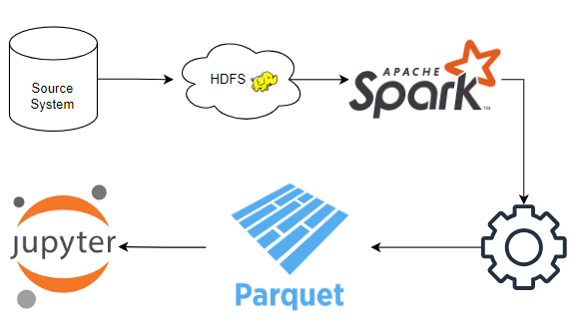
Fig. 2: Data lifecycle from source to model development.

Time Series Forecasting
The final stage of the project involves applying a number of forecasting models to our Store sales data sets to understand the accuracy of each model at predicting a look-forward window of 30, 60 and 90 days. Accuracy will be measured using RMSE and MAE.
The process will involve assessing the time series components e.g. Seasonality, Trend, Signal, residuals and whether the relationship between these is Additive or Multiplicative.
The models selected represent the most commonly used statistical algorithms for time series forecasting (ARIMA, Exponential Smoothing), a popular Kaggle ML algorithm (LightGBM), Deep Learning models (SimpleRNN, LSTM, N-BEATS, N-HiTS), and a modern statistical model (Prophet).
The final model is a naïve seasonal model that uses the same data point from 365 days ago, as a “Do Nothing” type baseline for comparison.
ARIMA (Ho, S.L. and Xie, M. (1998)) and Exponential Smoothing (Shastri et al. (2018)) were chosen as they are renowned as the baseline forecasting algorithms that have relatively low compute requirements, generalise well, are well understood and have regularly performed more advanced forecasting techniques on the appropriate datasets.
ARIMA (AutoRegressive Integrated Moving Average) performs well on univariate, stationary data i.e. the time series properties do not change over time. It works particularly well with long time series where the data points correlate with past values and little to no seasonal components.
Exponential Smoothing performs well with time series that have seasonal patterns, although not when there are multiple seasonal patterns. It also handles trending data quite well.
LightGBM (Light Gradient Boosting Machine) (Ke, G. et al. (2017)) is a gradient boosting framework that uses tree-based learning algorithms in the same family as XGBoost. LightGBM consistently outperforms more advanced algorithms in forecasting challenges and is commonly used in Kaggle competitions. In a recent study by Nixtla, they found they found that LightGBM was the best performing model on daily data, but this was on a dataset of over 1 Billion time series. Referenced by CQF, V.M., PhD, MBA (2023) but the access to the paper is pending approval by Nixtla (Nixtla | State of the art forecasting (no date)). Performs well with very large datasets with categorical variables and high dimensional data.
Deep learning models such as RNN (Recurrent Neural Networks), LSTM (Long Short-Term Memory), N-BEATS (Neural Basis Expansion Analysis for Time Series) and N-HiTS (Neural Hierarchical Time Series) were chosen due to they common use for time series or for their place at the SOTA for deep learning models.
RNN performs well with sequential data where the order and continuity are crucial. It favours medium sequence lengths and can struggle to learn longer term dependencies. They can be effected by the vanishing gradient problem so the choice of activation function i.e. leaky ReLU can help to mitigate this.
LSTM (Staudemeyer, R.C. and Morris, E.R. (2019)) is one of the most powerful dynamic classifiers publicly known. This network is well understpod and commonly used in time series forecasting. It performs well with long sequences of time series observations and when learning long term dependencies is important. LSTM is capable of learning complex, non-linear patterns but is very computationally expensive compared to simpler models.
N-BEATS (Oreshkin, B.N. et al. (2020)) is a deep neural network architecture based on backward and forward residual links and a very deep stack of fully-connected layer. It focuses on solving the univariate time series point forecasting problem. It has performed significantly better than previous M4 competition winners on the 100k time series dataset. It performs well with enough data. It requires significant amounts of data to be effective but handles seasonality, trend and non-linearity.
N-HiTS (Challu, C. et al. (2022)), address the problems of long horizon forecasting – volatily of predictions and computational complexity- by incorporating hierarchical interpolation and multi-rate data sampling techniques. This allows the model to assemble its predictions sequentially, emphasizing components with different frequencies and scales while also decomposing the input and building the forecast. It performs well with hierarchical time series and multi-level temporal patterns. This is a resource heavy model so requires a lot of compute power.
Unfortunately, due to issues with dependencies, I could not manage to implement N-HiTS (part of the darts library) as it was missing pytorch components that conflicted with other models in the study.
Prophet (Žunić, E. et al. (2020)) is a univariate model developed by Facebook that uses a decomposable time series model combining elements of trend, seasonality, and holidays. It is specifically designed to handle the types of data patterns typically seen in business forecasting tasks, such as daily observations with annual patterns and missing data. Prophet struggles when components of the time series are not additive. It also has a large number of tunable hyperparameters so can be very compute intensive while training.
The remainder will discuss the methodology in greater detail & discuss results, conclusions and next steps.MapReduce has the flexibility to run parallel Recurrent Neural Networks (Liu, Yang & Yang, et al (2015)) and Short-Term Load forecasting models (B. Deng, Y. Wen and P. Yuan(2020)), these approaches do not allow for the flexibility, speed of development and speed of deployment as solutions developed in PySpark in an online system or in

METHODOLOGY

Analytcis Lifecycle
The preferred development envionment for this project would have been to complete the entire project within the same Virtual environment, however, this was not feasible as the machine that was running the Virtual Machine (VM) did not have the necessary memory or processor requirements. To this end, the implementation was carried out across a number oF machines. 1) VM running an instance of Ubuntu 22.04.03 LTS. This VM was running on a Lenovo machine with 8GB of RAM and an Intel i3 processor, 2) v1 of model training was carried out on an Apple M2 Macbook Pro with 16G of RAM where the limitations in the training NN models using Adam and Prophet were encountered; Prophet would not fully install due to compilation issues with PyStan and 3) the final set of trainings were carried out on the Lenovo machine without GPU support and where the pytorch dependency issue with Sci-kit Learn was encountered; limiting the use of N-HiTS.

Project Management and Data Description
Using a CRISP-DM lifecycle model, this project begins with the understanding that the goal is to us modern data processing tools and forecasting methods to create the best possible solution, for a retall client, to forecast expected sales quantities for 30, 60 and 90 day windows based on the previous 365 days of sales data for each of its store formats.
The dataset used is a synthetic dataset provided by Dunnhumby for use in research and professional settings. There is no official licence agreement available and at the time of writing, I have not received feedback from Dunnhumby on the specifics of the licence for usage. (dunnhumby (2023a), dunnhumby (2023b)).

Data Storage and Aggregation
To store this data, Hadoop 3.2.4 was installed in the Ubuntu VM instance. The datasets were uploaded to the HDFS structure in the form of 117 CSV files; each ~40MB distributed across a single cluster. To access this data, Spark 3.2 was installed with pySpark 3.4.1 installed to support use of a Python in a Jupyter notebook to carry out the Spark based operations.
Data was aggregated at a daily total at various levels of granularity i.e. total, various levels of product differentiation, by store and by store type. This will support future works to perform product level forecasting on a large number of time series. In this particular case, the focus was on store types which provided 4 distinct Time Series – SS, MS, LS and XLS; small, medium, large, extra large. The data was cleansed to convert text fields to date and integer values and then aggregated on TOTAL_QTY of units sold and on TOTAL_SPEND using Spark SQL with data stored in Spark Dataframes. Once complete, the data was exported as a single Parquet file containing all 4 time series.

Exploratory Data Analysis (EDA) and Data Preparation
EDA was carried out to understand the nature of the data and to determine any preprocessing steps that would be necessary before the modelling phase. As discussed, the data contained 891 days (117 weeks) of sales history across 4 store formats. There are no missing data, as defined by Dunnhumby, and no bad data that requires cleaning e.g. text in number fields, inconsistent text formatting. Visualising the time series confirmed that all 4 appeared to be approximately stationary (fig 3). XLS stores are second lowest in terms of overall spend as there are a higher number of smaller store formats. At an individual store level, XLS is the highest spend store format. Figure 4 shows a violin plot of the overall daily sales totals. We see that values for each time series are quite tightly packed in a small range of values but with some outliers that can be explained by season spikes and troughs before, during and after Christmas at the end of December and beginning of January.
For all stores, an STL decomposition was carried to determine seasonality, trend, base and nature.
In addition, an Augmented Dickey-Fuller (ADF) and Kwiatkowski–Phillips–Schmidt–Shin (KPSS) were carried out to determine stationarity. The visualisation of the time series suggested that there was no significant trend, so there were no tests employed to test for trend e.g. Mann-Kendall test. The ADF is a test for stationarity and trend statiority where the null hypothesis is that the time series is not stationary and the KPSS test null hypothesis is the opposite where the time series is stationary.
For SS, ADF p-value had a p-value of 1.4e-5 and KPSS p-value of 0.01. This suggest, in that there the time series is trend stationary and may require de-trending before using ARIMA.
For MS, ADF: 1.2e-9 and KPSS: 0.01. This again suggests trend stationarity with de-trending required before applying ARIMA.
Both LS; ADF: 9.3e-7 & KPSS: 0.1 and XLS; ADF:1.6e-17 & KPSS: 0.1 indicate that these time series are stationary without significant trend.
All time series have a 12 month seasonality around Christmas. With ARIMA, we would normally de-trend and de-season the time series but since we will be using Auto-ARIMA from the pmdarima package, this will be accounted for in the hyper-parameter tuning, Exponential Smoothing can function well with a single seasonal component so will be OK to proceed, prophet is designed to account for trend and seasonality so will be OK and the ML / DL ,models do not require component processing. For all store formats, their was no significant difference in the distribution of errors whether using a multiplicative or additive relationship between time series components.
For LGBM, RNN, LSTM we MinMax normalise each time series to help in reducing the range of error values during training. We inverse the transformation and calculate of accuracy metrics.
Our training data for the univariate models i.e. ARIMA, Exponential smoothing and N-BEATS will consistent of all data up to the last 90 days of the time series. The test data will be the last 90 days.
For multivariate models, we will use sequences of 365 days to provide a point forecast for the next day i.e. use t-365, t-364 to t-1 to predict t. Validation will be carried out by walking forward with a moving window of 365 days to predict each subsequent value, which includes the previously predicted values..
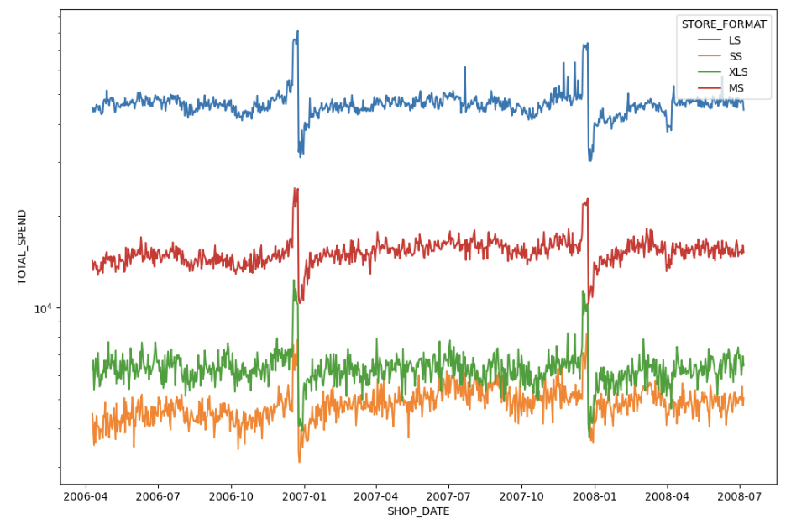
Figure 3 – Plot of 4 store format time series. 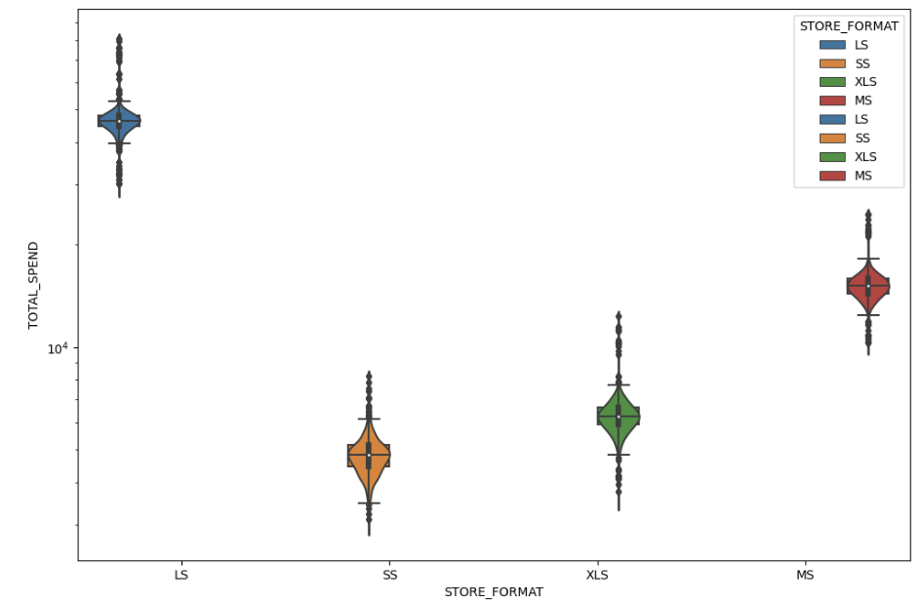
Figure 4. Boxplot of 4 store formats

Time Series Forecasting
The first model applied was a Seasonal Naïve model. This simply uses the value from 365 days ago (t-365) as the forecast. This serves as the “Do Nothing” type condition and will serve as a baseline for comparison for the rest of our models.
Exponential Smoothing is a time series forecasting method that aims to capture and predict future data points by assigning exponentially decreasing weights to past observations. It is particularly effective for forecasting data with no clear trend or seasonality. Exponential Smoothing comprises three main components:
α: the level component represents the current value of the time series and is updated based on the weighted average of the most recent observations. The smoothing parameter 'α' controls the weight assigned to the most recent observation.
β: the trend component captures the underlying trend in the data, reflecting its direction and rate of change. 'β' is the smoothing parameter for the trend component.
γ: For data exhibiting seasonal patterns, the seasonality component accounts for periodic fluctuations. 'γ' is the smoothing parameter for seasonality.
All values of alpha, beta and gamma should be between 0 and 1. Hyperparameter tuning was carried out by fitting multiple models using a selection of values from 0 – 1. By using MSE as the loss function, the best scoring parameters were chosen for the final fitted model.
ARIMA (Ho, S.L. and Xie, M. (1998)) is a time series forecasting method that combines past observations, differencing to make data stationary, moving average components and auto-correlations to predict future values. ARIMA has 3 main components:
p: the autoregressive (AR) order, indicating how many past observations are considered for predicting future values.
D: the order of differencing, which determines the number of differencing operations required to make the time series stationary.
Q: the order of the moving average (MA) component, specifying the number of past forecast errors considered for predictions.

In this case, we used Auto ARIMA from the PMDARIMA library. This process has built in hyper parameter tuning to find the best fit model for the data.
Training was performed on all data prior to the n-90 th data point in order to give the algorithm enough data to learn the time series pattern.
LightGBM s a gradient boosting framework that minimizes the loss function to optimize the model during training. For each data point in the training dataset, the gradient of the loss function with respect to the current prediction is calculated. The model builds decision trees in a leaf-wise manner. It selects the best split for a leaf that results in the largest reduction in the loss function. The gradient is used to make this decision. direction and magnitude of the error. Once a leaf is determined, the predicted values for the data points falling into that leaf are calculated. These predicted values are then adjusted based on a learning rate. Hyperparameter tuning was carried out using GridSearch with a range of typical values across: 'learning_rate', 'n_estimators', 'max_depth':, 'num_leaves' where the loss function was RMSE to determine the best model for regression modelling.
RNN are a class of artificial neural networks designed for processing and analyzing sequential data. This makes them an ideal choice for time series analysis. Based on the SimpleRNN implementation in Keras. Hyperparameter tuning was carried out on the number of hidden layers in the network, activation functions, a range of dropout rates to prevent overfitting, batch normalisation to normalize activations in the hidden layers and learning rate for the optimiser. The initial training was performed on a Mac M2 and so required the use of a legacy version of ADAM, however the final training was done using an intel chipset and the latest version of ADAM. Training was carried out over 10 trials of 200 epochs. Early Stopping was enabled with a patience of 10 to prevent overfitting.
LSTM is a specialised version of an RNN that excels in capturing long-range dependencies and patterns in sequential data. LSTMs use memory cells and gating mechanisms to control information flow, allowing them to store and retrieve information over long sequences. Hyperparameter tuning was carried on the same parameters as the RNN with the addition of kernel initialisation functions to train using glorot and he initialisation methods where the initial weighs of the network are chosen from a uniform and normal distribution respectively. It can help prevent issues like exploding or vanishing gradients and slow convergence,
Both RNN and LSTM used RandomSearch from the Keras Tuner library to efficiently using a selection of parameters while minimising the necessary training time for a complete GridSearch.
Prophet is an open-source forecasting tool developed by Facebook. It is designed for time series forecasting and is particularly suitable for business applications. It is capable of handling time series data with multiple seasonalities and holidays. Hyperparameter tuning was carried out by predefining a dictionary of parameters and values. This was using to generate a list of all the possible permutations of parameter values with a model trained for each set with the aim of maxmising the RMSE loss function. The selected hyperparameters only use a small subset of values and a subset of the available tunable hyperparameters as training time was growing considerably with each additional fold.
N-BEATS was added as a selected model quite late in the project after learning of it during a review of the Nixtla mega study. The model used is a slightly augmented version of the Hello World tutorial provided by the team that develop the darts library. Future versions of this analysis will explore the available parameters in more detail. This model has outperformed the winners of the M4 forecasting competition so deserves a deeper dive to understand how to be fully utilised.
N-HiTS was another model discovered quite late. After 1 successful training, there were issues with library dependencies that required either it or Prophet to be used in the analysis. Due it ubiquity and a request from my work manager, I chose Prophet but in future versions of this work, it will be necessary to create separate virtual environments that will allow for separate analyses to take place.
Once trained, models were to predict the next 30, 60 and 90 days of total spend for each store format given a 365 day sequence of observations. MAE and RMSE were measured to assess accuracy.

RESULTS
Upon completion on all model training, each model predicted a 30, 60 and 90 window forward. The below detail the MAE and RMSE scores achieved by each model per look forward window and per store format.
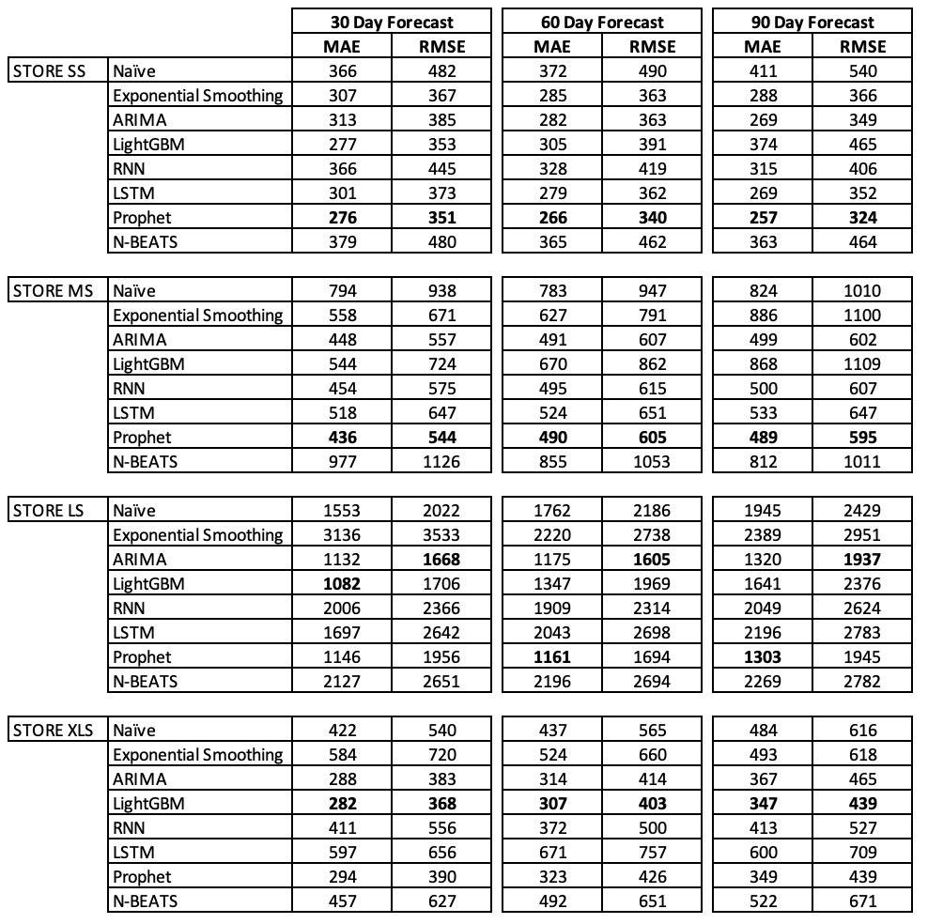
The results illustrate that Prophet is the best performing model chosen for the given datasets. Given that prophet is designed to perform well on data with trend and annual seasonality that is typical of business operations this is to be expected. Deep Learning models did not perform well consistently on any given task. LSTM performed best on middle and long term forecasts for time series that had trend i.e. SS and MS but not as well on the stationary time series. RNN performed reasonably across all tasks with no significant deviation – consistently middle of the pack. N-BEATS performed poorly on all datasets. This is likely due to the limited amount of tuning that the model received as well as having few observations. RNN and LSTM perform well with muiltivariate data and so any further work should involve the development of additional features such as lagged values to enrich the forecast data. N-BEATS could use more observations or maybe take all time series across all tasks and learn to forecast across all store formats. In all cases, training should be performed on a GPU enabled device to speed up training and allow for a much greater set of tuning parameters. The datsets were likely much too small for DL to perform effectively.
ARIMA performed considerably better than DL and with lower footprint for training.
Exponential smoothing performed the worst, in some cases performing worse than the naïve seasonal model. This is likely due to the models limitations in handling seasonality. All time series had a significant spike in December each year that would ruin the overall RMSE and MAE for a moving average model.
LightGBM was the second best model overall and with the faster speed of prediction. For shorter term forecasts, once trained LightGBM would be an ideal candidate for future predictions. Prophet requires significant training time and the speed to prediction is slower. On a large number of time series, LightGBM would likely be more useful and cost effective and in cases where a smaller number of time series are present with a lower requirement for model retaining then Prophet would likely be the best. Additional work is required to understand the potential for improvement by including additional features for NN and LightGBM, Covariates for Prophet.

FUTURE WORK
To further enhance our neural network models, additional development is needed. Firstly, we should enrich our model-building by harnessing larger datasets to ensure the NNs have enough data to learn more intricate patterns from. We should improve our use of feature engineering techniques to enhance the predictive power of multivariate models e.g. NN and LightGBM, by introducing categorial flags, lagging observations or a delta to seasonal spikes. This aspect should include the exploration of more robust hyperparameter tuning strategies to fine-tune our models for optimal performance.
Additionally, we should capitalize on the power of GPU-supported environments to speed up our model development and training processes. Leveraging Apache Spark for automation and scalability, we can expand our analysis to encompass product-level forecasting to include the inherent intricacies of this data. Lastly, to gain a more profound understanding of forecast accuracy, we should delve into advanced methods like conformal prediction. This approach allows us to meticulously calibrate our predictions, ensuring they align closely with real-world outcomes. Through these combined efforts, we can significantly enhance the precision and reliability of our forecasting predictions while optimizing the efficiency of our workflow.

References

G. Eason, B. Noble, and I. N. Sneddon, “On certain integrals of Lipschitz-Hankel type involving products of Bessel functions,” Phil
Dutta, A. and Hasan, R. (2013) ‘How Much Does Storage Really Cost? Towards a Full Cost Accounting Model for Data Storage’, in Lecture Notes in Computer Science, vol. 8193, pp. 29-43. doi: 10.1007/978-3-319-02414-1_3.
Nambiar, A. and Mundra, D. (2022) ‘An Overview of Data Warehouse and Data Lake in Modern Enterprise Data Management’, Big Data and Cognitive Computing, 6(4), p. 132. Available at: https://doi.org/10.3390/bdcc6040132.
Suleykin, A., Bobkova, A., Panfilov, P. and Chumakov, I. (2021) ‘Efficient Data Exchange Between Typical Data Lake and DWH Corporate Systems’, in 2021 International Conference on Electrical, Computer and Energy Technologies (ICECET), Cape Town, South Africa, pp. 1-6. doi: 10.1109/ICECET52533.2021.9698468.
Fajardo-Toro, C., Mula, J. and Poler, R. (2019) ‘Adaptive and Hybrid Forecasting Models—A Review: Proceedings of the 11th International Conference on Industrial Engineering and Industrial Management’, in, pp. 315–322. Available at: https://doi.org/10.1007/978-3-319-96005-0_38.
CQF, V.M., PhD, MBA (2023) ‘What Truly Works in Time Series Forecasting — The Results from Nixtla’s Mega Study’, Medium, 15 September. Available at: https://valeman.medium.com/what-truly-works-in-time-series-forecasting-the-results-from-nixtlas-mega-study-78eda5133622 (Accessed: 25 September 2023).
Phoenix Nap (2020) HDFS Components. Available at: https://phoenixnap.com/kb/wp-content/uploads/2021/04/hdfs-components-namenode-datanode-datanode.png (Accessed: 25 September 2023).
Leturgez, L. (2020) ‘On Spark Performance and partitioning strategies’, datalex, 3 September. Available at: https://medium.com/datalex/on-spark-performance-and-partitioning-strategies-72992bbbf150 (Accessed: 25 September 2023).
Pan, Shengti (2016), "The Performance Comparison of Hadoop and Spark". Culminating Projects in Computer Science and InformationTechnology. 7.
dunnhumby (2023a) Let’s Get Sort Of Real User Guide. Available at: https://www.dunnhumby.com/wp-content/uploads/2023/08/Let_s-Get-Sort-of-Real-User-Guide-dunnhumby.pdf (Accessed: 25 September 2023).
dunnhumby (2023b) Let's Get Sort Of Real dataset. Available at: https://www.dunnhumby.com/source-files/ (Accessed: 25 September 2023).
Madhugiri, D. (2022) ‘Apache Spark Vs. Hadoop MapReduce – Top 7 Differences’, Analytics Vidhya, 14 June. Available at: https://www.analyticsvidhya.com/blog/2022/06/apache-spark-vs-hadoop-mapreduce-top-7-differences/ (Accessed: 25 September 2023).
B. Deng, Y. Wen and P. Yuan(2020), "Hybrid Short-Term Load Forecasting using the Hadoop MapReduce Framework," IEEE Power & Energy Society General Meeting (PESGM), Montreal, QC, Canada, 2020, pp. 1-5, doi: 10.1109/PESGM41954.2020.9282094.
Liu, Yang & Yang, Jie & Huang, Yuan & Xu, Lixiong & Li, Siguang & Qi, Man. (2015). MapReduce Based Parallel Neural Networks in Enabling Large Scale Machine Learning. Computational Intelligence and Neuroscience. 2015. 1-13. 10.1155/2015/297672.
Plase, Daiga & Niedrite, Laila & Taranovs, Romans. (2017). A comparison of HDFS compact data formats: Avro versus Parquet. Mokslas - Lietuvos ateitis. 9. 267-276. 10.3846/mla.2017.1033.
Karlsson, M. (2023) Pandas, Spark, and Polars — When To Use Which?, Medium. Available at: https://betterprogramming.pub/pandas-spark-and-polars-when-to-use-which-f4e85d909c6f (Accessed: 25 September 2023).
Nguyen, B.D.Q., Hewett, R. and Dang, T. (2020) ‘Visual Features for Multivariate Time Series’, in Proceedings of the 11th International Conference on Advances in Information Technology. New York, NY, USA: Association for Computing Machinery (IAIT2020), pp. 1–8. Available at: https://doi.org/10.1145/3406601.3406621.
Adaltas (2020) ’Comparison of different file formats in Big Data’. Available at: https://www.adaltas.com/en/2020/07/23/benchmark-study-of-different-file-format/ (Accessed: 25 September 2023).
Ho, S.L. and Xie, M. (1998) ‘The use of ARIMA models for reliability forecasting and analysis’, Computers & Industrial Engineering, 35(1), pp. 213–216. Available at: https://doi.org/10.1016/S0360-8352(98)00066-7.
Shastri, Sourabh & Sharma, Amardeep & Mansotra, Vibhakar & Sharma, Anand & Bhadwal, Arun & Kumari, Monika. (2018). A Study on Exponential Smoothing Method for Forecasting. International Journal of Computer Sciences and Engineering. 6. 482-485. 10.26438/ijcse/v6i4.482485.
Ke, G. et al. (2017) ‘LightGBM: A Highly Efficient Gradient Boosting Decision Tree’, in Advances in Neural Information Processing Systems. Curran Associates, Inc. Available at: https://proceedings.neurips.cc/paper_files/paper/2017/hash/6449f44a102fde848669bdd9eb6b76fa-Abstract.html (Accessed: 25 September 2023).
Nixtla | State of the art forecasting (no date). Available at: https://www.nixtla.io/ (Accessed: 25 September 2023). (Waiting for approval to have access to the article)
Staudemeyer, R.C. and Morris, E.R. (2019) ‘Understanding LSTM -- a tutorial into Long Short-Term Memory Recurrent Neural Networks’. arXiv. Available at: https://doi.org/10.48550/arXiv.1909.09586.
Oreshkin, B.N. et al. (2020) ‘N-BEATS: Neural basis expansion analysis for interpretable time series forecasting’. arXiv. Available at: https://doi.org/10.48550/arXiv.1905.10437.
Challu, C. et al. (2022) ‘N-HiTS: Neural Hierarchical Interpolation for Time Series Forecasting’. arXiv. Available at: https://doi.org/10.48550/arXiv.2201.12886.
Žunić, E. et al. (2020) ‘Application of Facebook’s Prophet Algorithm for Successful Sales Forecasting Based on Real-world Data’, International Journal of Computer Science and Information Technology, 12(2), pp. 23–36. Available at: https://doi.org/10.5121/ijcsit.2020.12203.
Ho, S.L. and Xie, M. (1998). The use of ARIMA models for reliability forecasting and analysis. Computers & Industrial Engineering, 35(1–2), pp. 213-216. ISSN 0360-8352. [Online] Available at: https://doi.org/10.1016/S0360-8352(98)00066-7.
.
IEEE conference templates contain guidance text for composing and formatting conference papers. Please ensure that all template text is removed from your conference paper prior to submission to the conference. Failure to remove template text from your paper may result in your paper not being published.

